**Jenkin task Day-03 Name: Mohd Ehtesham Date: August 28, 2024**

1. Create one jenkins job using the below code and create three stages.

Created one v profile job:

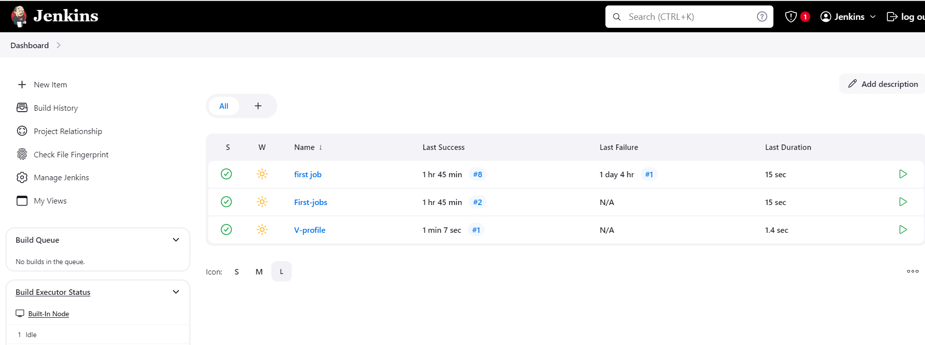

stage1: Git clone to download the source code.

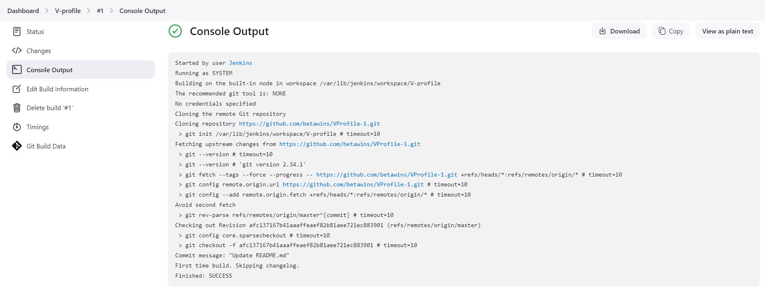

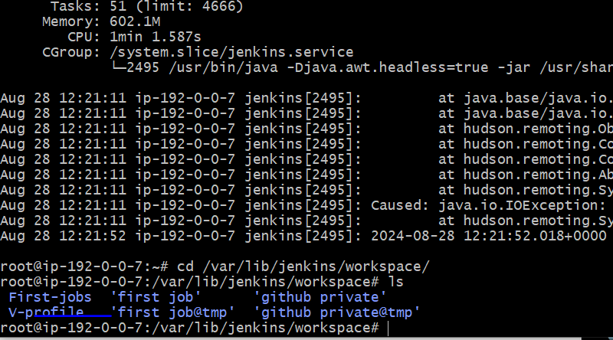

stage2: Sonarqube Integration to check the quality of code

Installed sonarqube:-

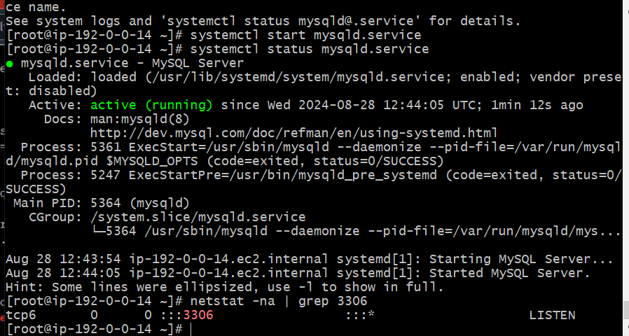

Database has been updated

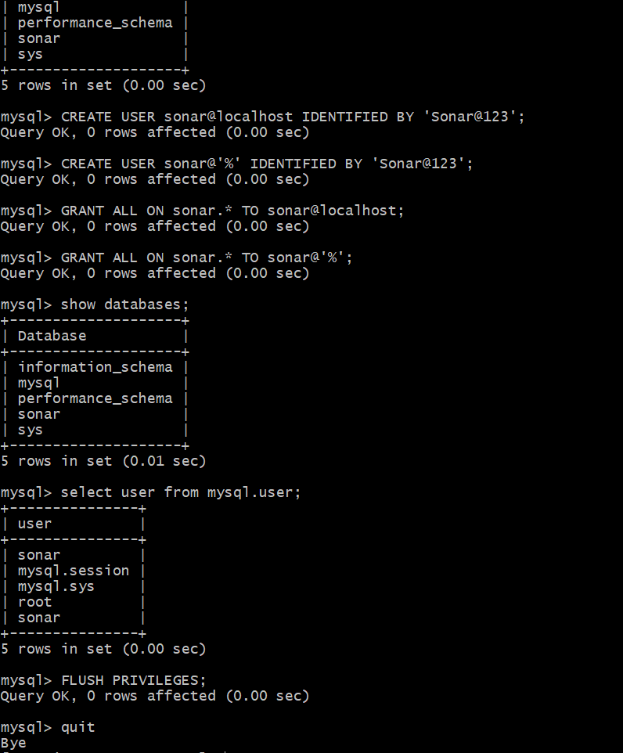

Sonarqube

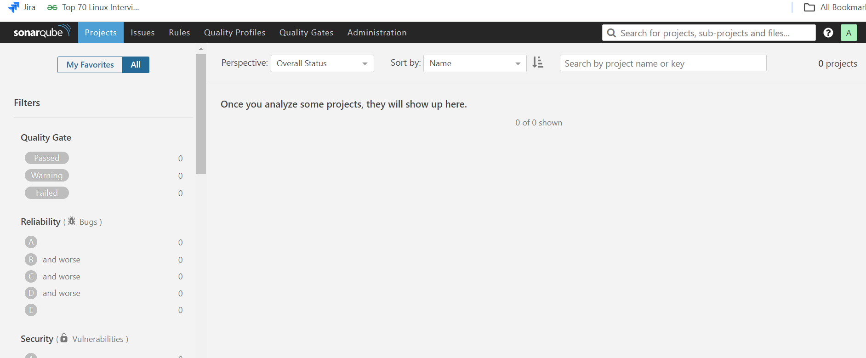

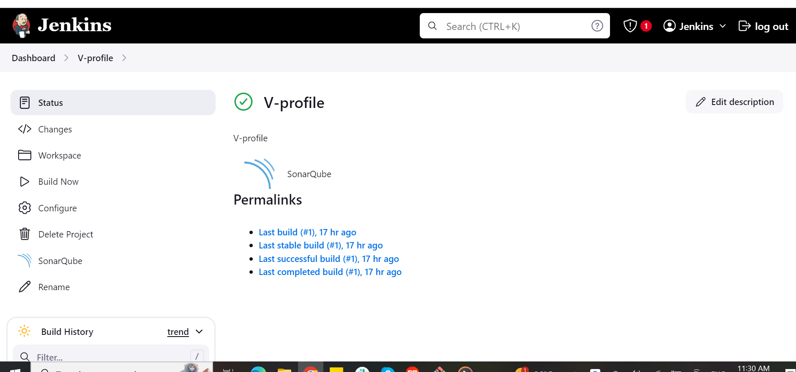

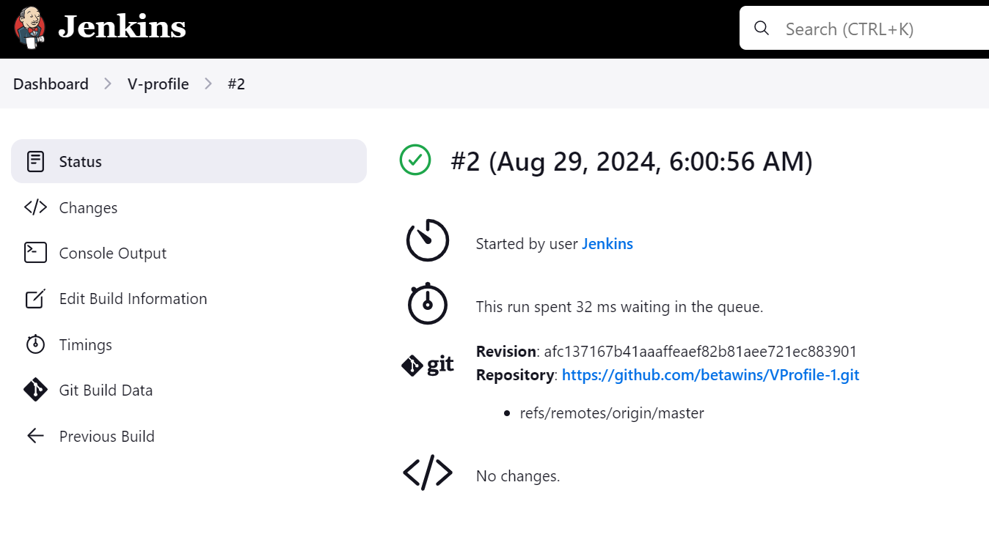

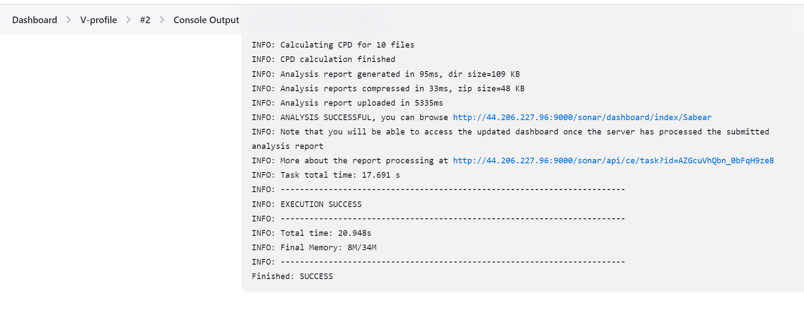

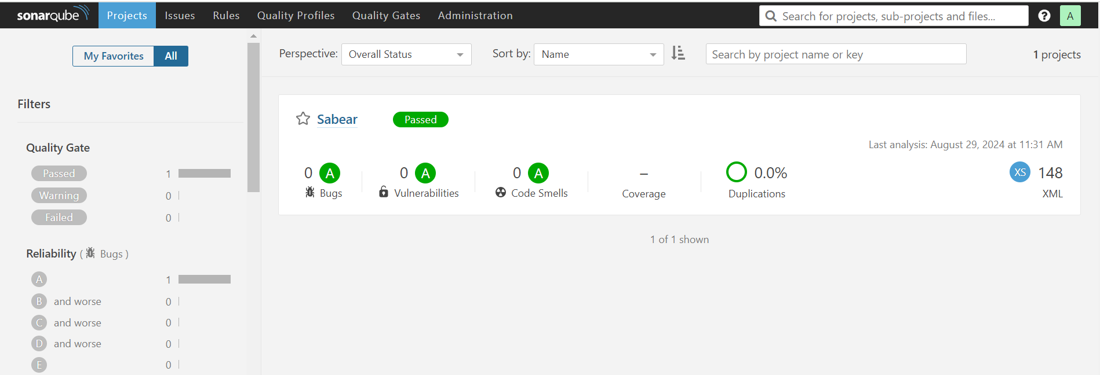

stage3: Slack Integration to send the alerts to slack. URL: [https://github.com/betawins/VProfile-1.git](https://github.com/betawins/VProfile-1.git" \t "https://app.slack.com/client/T03TRQ064Q0/_blank)

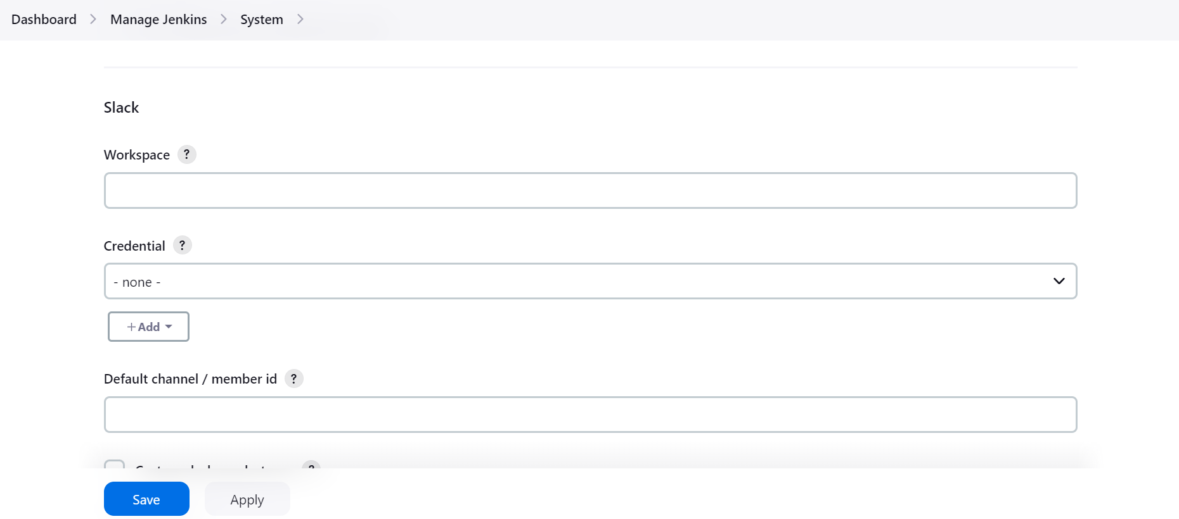

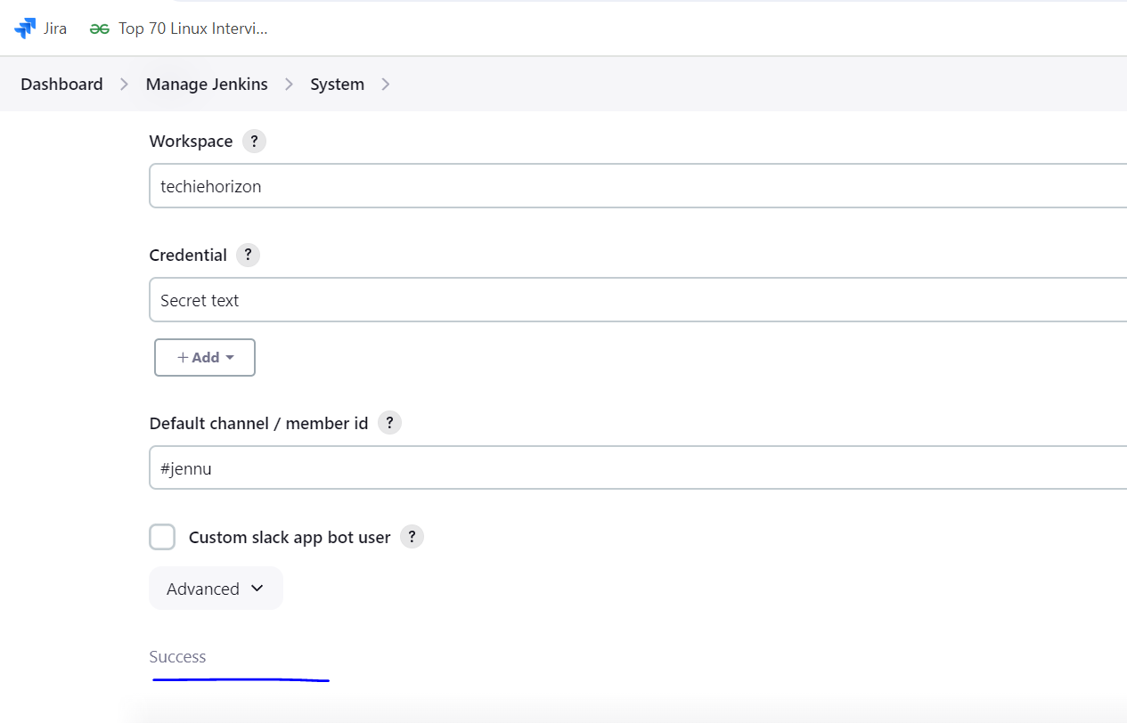

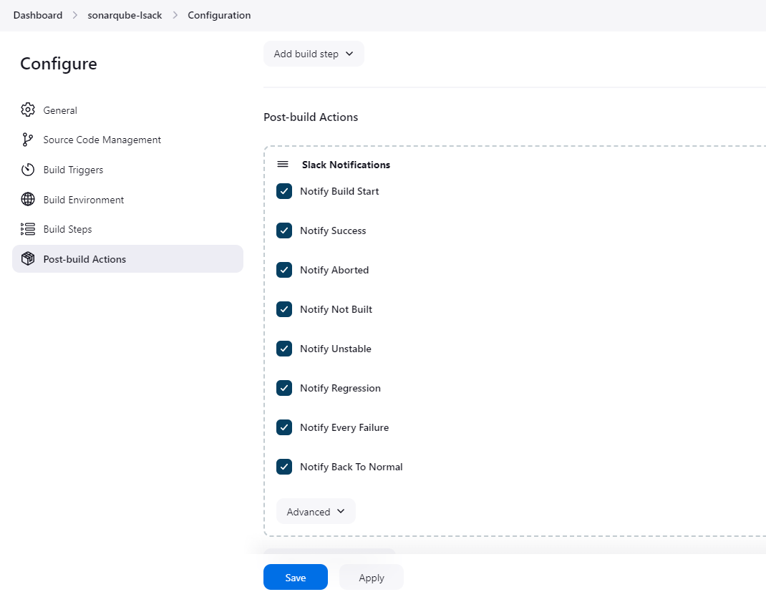

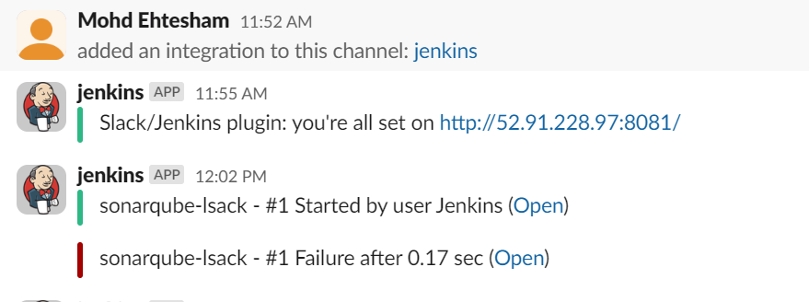

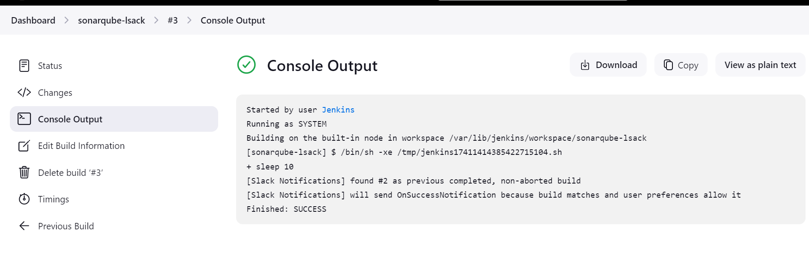

1. 1) Create one jenkins job using the below code and create three

stages. stage1: Git clone to download the source code.

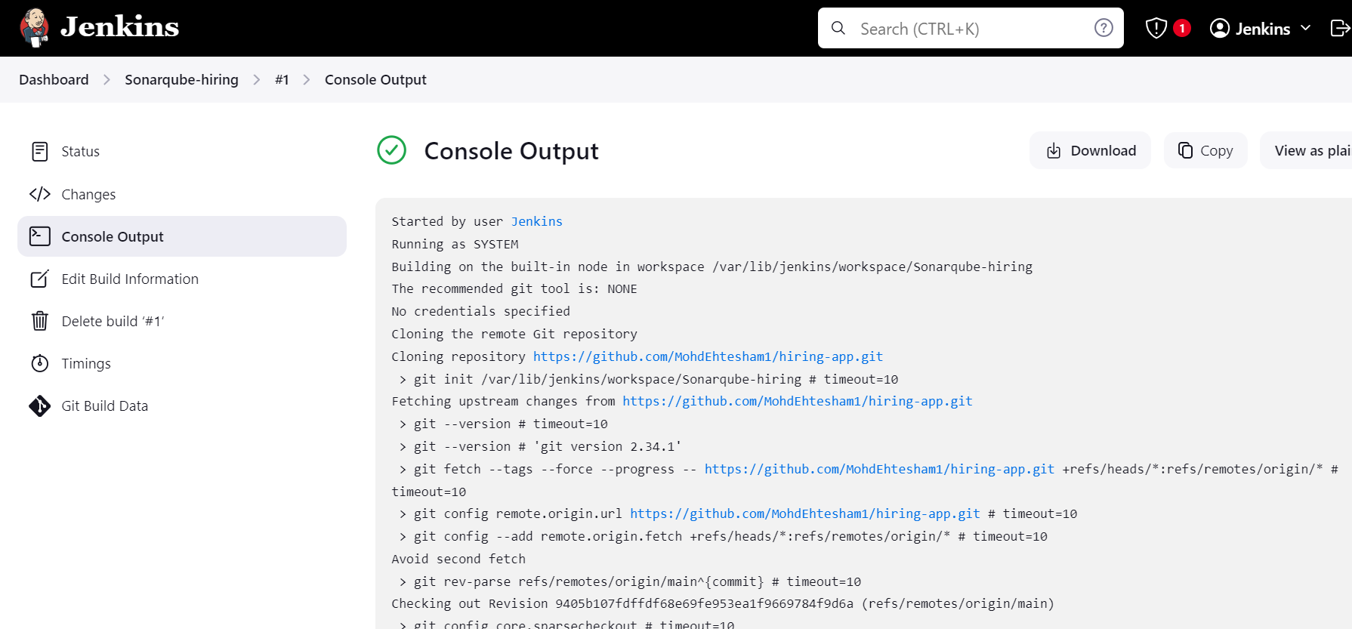

stage2: Sonarqube Integration to check the quality of code

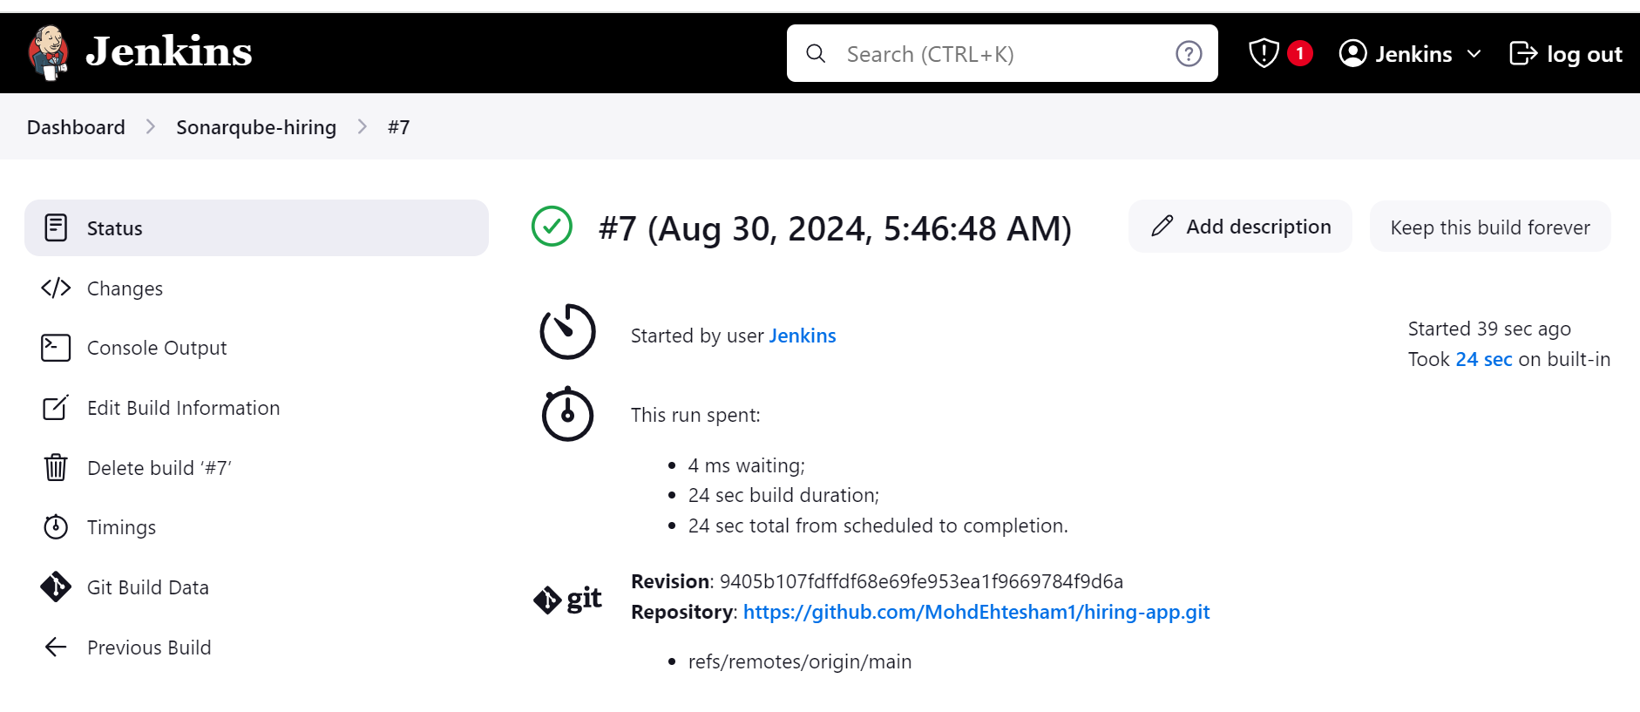

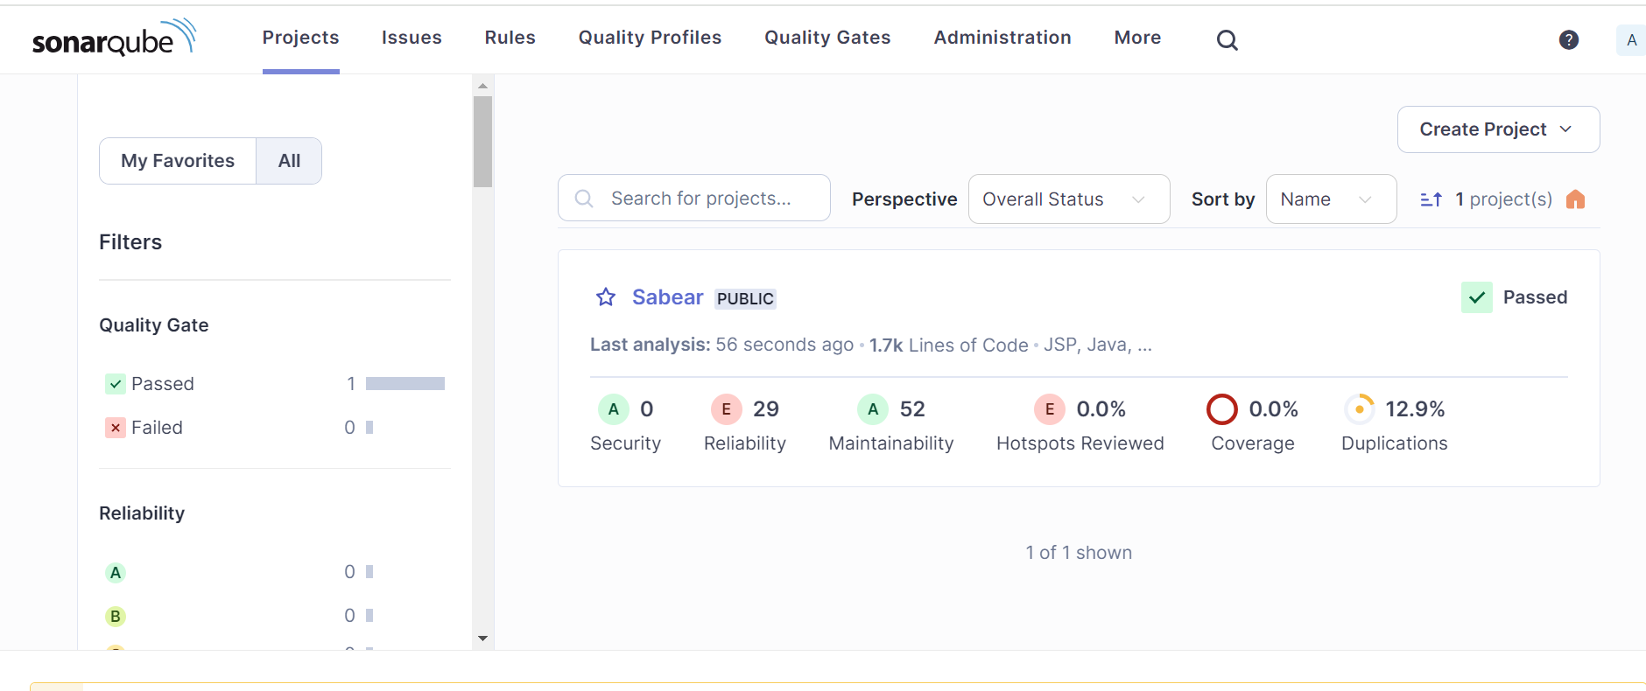

stage3: Slack Integration to send the alerts to slack. URL: [https://github.com/betawins/hiring-app.git](https://github.com/betawins/hiring-app.git" \t "https://app.slack.com/client/T03TRQ064Q0/_blank)

